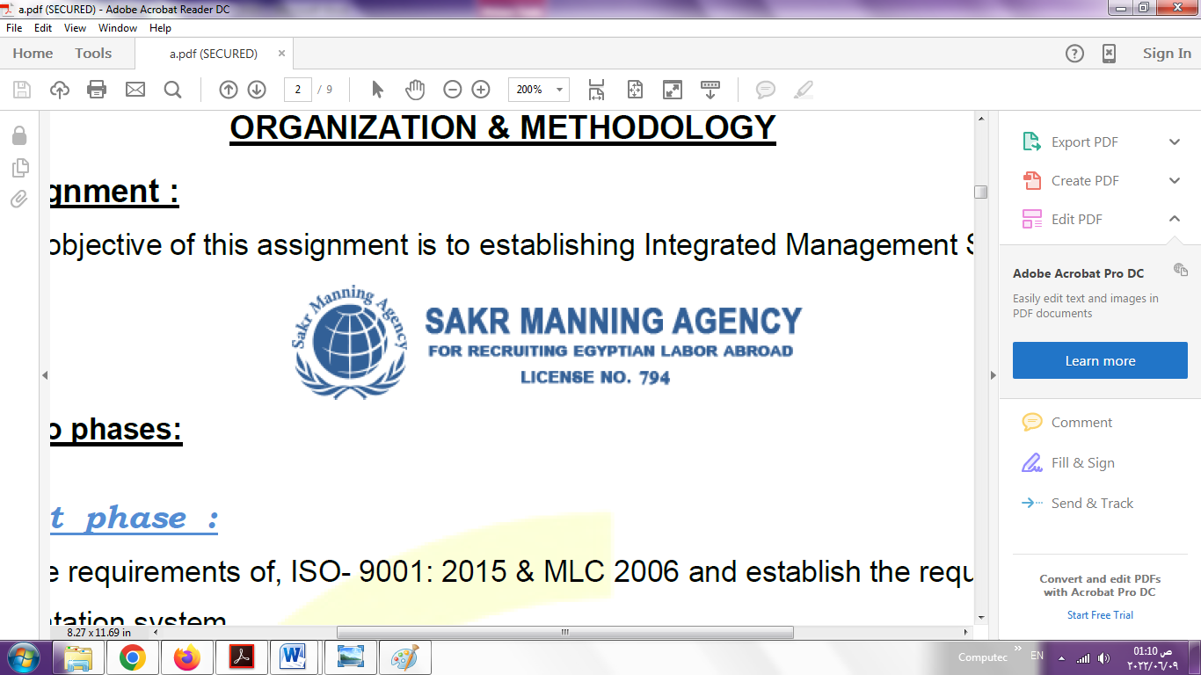 | SAKR MANNING AGENCY  FOR RECRUITING EGYPTIAN LABOR ABROAD | Issue Date | 15.05.2022
 |  | Revision Date | 19.07.2022
 | Crewing Management Manual    Seafarer Employment Application | Revision | 1.1
 |  | Page | 3

Application For Position as | 2EN ENGINEER
Register Code. | EO-1.015
Other Position (If Any)
Register Date | 7/2/2023
Last up Date Data
Expected Salary

1. PERSONAL DETAILS
Full Name |  | TAMER MOHAMED HAMOUDA ELHASSAININ
Date Of Birth |  | 08.01.1975 |  |  |  |  |  |  | Place Of Birth |  |  |  |  |  |  |  | DAMITTA
Nationality |  | EYGPTIAN |  |  |  |  |  |  | Marital Status |  |  |  |  |  |  |  | Single ☐ |  |  |  |  |  |  |  | Married YAS
Height (Cm) |  | 175 |  |  |  |  |  |  | Overall Size |  |  |  |  |  |  |  | 54 |  |  |  |  | Shirt Size |  |  |  |  |  | XL
Weight (Kg) |  | 85 |  |  |  |  |  |  | Trouser Size |  |  |  |  |  |  |  | 34W 32L |  |  |  |  | Shoes Size |  |  |  |  |  | 43
2. EDUCATION
College / School
Marline Test |  | Issued Date |  |  |  |  | Result % |  |  |  | Issued By (Authority) |  |  |  |  |  |  |  |  |  | Issued At
English Language |  | Fluent ☐ |  |  |  |  |  | Good X |  |  |  |  | Average ☐ |  |  |  |  |  |  |  | Poor ☐
……… Language  ( ) |  | Fluent ☐ |  |  |  |  |  | Good X |  |  |  |  | Average ☐ |  |  |  |  |  |  |  | Poor ☐
3. CONTACT DETAILS
Home Address / City |  |  | DAMITTA . EYGPT
E-Mail |  |  | tamerhamouda99@gmail.com |  |  |  |  |  |  | Mobile / Tel |  |  |  |  |  | +201003345224 |  |  |  |  |  |  | +20572347231

4. TRAVEL DOCUMENTS
Type |  | Document No. |  |  |  | ISS. Date |  |  | Exp. Date |  |  |  |  | ISS. By (Authority) |  |  |  |  |  |  |  |  |  | Place of Issue
Passport |  | A22005223 |  |  |  | 07.03.2018 |  |  | 06.03.2025 |  |  |  |  | Egyptian Authority
Seaman Book |  | S00024496 |  |  |  | 17.08.2022 |  |  | 30.11.2026 |  |  |  |  | EAMS |  |  |  |  |  |  |  |  |  | Alex.
Other Seaman Book |  | 036625 |  |  |  | 28.12.2022 |  |  | 28.12.2027 |  |  |  |  | CH.ENG |  |  |  |  |  |  |  |  |  | HONDURAS

5. PROFESSIONAL QUALIFICATION / CERTIFICATE OF COMPETENCY
Certificate Name |  |  |  |  | Number | Issue Date |  |  |  |  |  | Expiry Date |  |  |  |  |  | Issued By |  |  |  |  |  |  |  |  | Issued At
COC |  |  |  |  | 5119 | 23.08.2022 |  |  |  |  |  | 30.11.2026 |  |  |  |  |  | EAMS |  |  |  |  |  |  |  |  | Alex.
GOC |  |  |  |  |  |  |  |  |  |  |  |  |  |  |  |  |  | NTRA |  |  |  |  |  |  |  |  | Cairo
D.P. INDUCTION
D.P. ADVANCED
D.P. OPERATOR (UNLIMITED)
6. NEXT OF KIN
Full Name | WALAA ELTANAHY |  |  |  |  |  |  |  |  |  |  |  |  |  | Relationship |  |  |  |  | WIFE
Address | DAMEITTA EYGPT
Tel. No. | +20572347231 |  |  |  |  |  |  |  |  | Mobile |  |  | +201095667343
7. HEALTH CERTIFICATES & VACCINATIONS
Flag State |  |  |  | Number |  |  | Issue Date |  |  |  |  | Expiry Date |  |  |  |  |  |  | Issued By |  |  |  |  |  |  | Issued At
International Medical |  |  |  | 05192 |  |  | 25.08.2022 |  |  |  |  | 24.08.2024 |  |  |  |  |  |  | EAMS |  |  |  |  |  |  | Alex.
Yellow Fever |  |  |  |  |  |  | 21.11.2008 |  |  |  |  | XXXXXX |  |  |  |  |  |  | Ministry of Health
Cholera |  |  |  |  |  |  |  |  |  |  |  |  |  |  |  |  |  |  | Ministry of Health
Covid-19 |  |  |  | Vaccination Name |  |  | First Dose |  |  |  |  | Second Dose |  |  |  |  |  |  | (Other Does or Remarks)
 |  |  |  | JOHNSON |  |  | SINOVAC |  |  |  |  | SINOVAC

8. MARINE COURSES
Course Name | Number | Issue Date | Expiry Date | Issued By / At
Personal Survival Techniques
Proficiency In Personal Survival Techniques | 41581/21/EG | 30.11.2021 | 29.11.2026 | ARAB ACADEMY
Fire Prevention and Fire Fighting | ALS C–13/CH-3344 | 12.12.2022 | 12.12.2027 | ALS GREECE
Advanced Fire Prevention and Fire Fighting | 41891/21/EG | 02.12.2021 | 01.12.2026 | ARAB ACADMY
Elementary First Aid | 42791/21/EG | 09/12/2021 | 08.12.1026 | ARAB ACADMY
Medical Care Studies | ALS C-16/CH-3332 | 12.12.2022 | 12.12.2027 | ALS GREECE
Personal Safety and Social Responsibilities | 42571/21/EG | 09/12/2021 | 08/12/2026 | ARAB ACADMY
Proficiency Of Security Awareness Training Seafarers | 41510/21/EG | 30/11/2021 | 28/11/2026 | ARAB ACADMY
Proficiency as a ship Security officer ( PSSO ) | A22005223 | 28.12.2022 | 28.12.2027 | HANDURASE
Proficiency In Survival Craft & Rescue Boats | 42322/21/EG | 07/12/2021 | 06/12/2026 | ARAB ACADMY
G.M.D.S.S
Communications
Advanced Communications
ECDIS Advanced Simulator (Management Level)
ECDIS Simulator (Operation Level)
Prevention and Combating of Marine Pollution | 37421/17/EG | 26.10.2017 | XXX | ARAB ACADMY
Radar & ARPA Simulator and Search &rescue
ARPA Simulator and Search
Marine Radar and automatic Radar Plotting
Bridge resource Management (B.R.M)
Engine resource Management (E.R.M) | ALS C-24/CH-1770 | 12.12.2022 | 12.12.2027 | ALS GREECE
Navigational Watch keeping
Proficiency for Rating forming part of Navigational watch (II/4) |  |  |  | EAMS / Alex.
High voltage training – operation of ship (1000 Volt and More) | ALS C-43/CH-1762 | 12.12.2022 | 12.12.2027 | ALS GREECE
Passenger Safety Cargo Safety and Hull integrity | NXD 745
Crowd Management Training | NXA 734 | 06.07.2020 | 22.06.2025 | NAVAL POST GSI
Crisis Management and Human Behavior Training | NXB 772 | 06.07.2020 | 24.06.2025 | NAVAL POST GSI
Safety training for Personal Prov. Direct Passengers | NXC 760 | 06.07.2020 | 27.06.2025 | NAVAL POST GSI
Practical Ability to Prepare Meals and (MLC 2006)
Personal Hygiene and Envir. Protection (MLC 2006)
Safety and Health in the Provision Meals (MLC 2006)
Food Storage and inventory Control (MLC 2006)
Ships Cook Certificate (MLC 2006) |  |  |  | EAMS / Alex.
Abel Seafarer Deck
Proficiency for Abel Seafarer Deck ( II/5 ) |  |  |  | EAMS / Alex.
Engineering Watch keeping |  |  |  | EAMS / Alex.
Proficiency for Rating forming part of a watch in engine room
Abel Seafarer Engine
Proficiency for Abel Seafarer Engine ( III/5 ) |  |  |  | EAMS / Alex.
Electro Technical Rating
Proficiency for Electro Technical rating ( III/7 ) |  |  |  | EAMS / Alex.

COMPLETE SEA – SERVICE DETAILS

Name: |  |  |  |  |  |  |  | Rank: |  |  |  |  |  |  |  | Register Code:
Company Name |  |  | Rank |  | Vessel Name |  |  |  | Signed On |  |  | Signed Off |  |  |  | Period |  |  | Vessel Type |  | D.W.T. |  |  |  |  | Engine Type |  |  | BH | KW
UNIMAR SHIPPING |  |  | 2EN ENG |  | UNE-K |  |  |  | 12.12.2006 |  |  | 31.10.2007 |  |  |  | 11 MONTH |  |  | GENERAL CARGO |  | 2160.2 |  |  |  |  | MAK 8M453AK |  |  | 2631 | 1949
UNIMAR SHIPPING |  |  | 2EN ENG |  | UNE-K |  |  |  | 20.12.2007 |  |  | 05.08.2008 |  |  |  | 9 MONTH |  |  | GENERAL CARGO |  | 2160.2 |  |  |  |  | MAK 8M453AK |  |  | 2631 | 1949
UNIMAR SHIPPING |  |  | 2EN ENG |  | UNE-K |  |  |  | 01.02.2009 |  |  | 23.07.2009 |  |  |  | 5 MONTH |  |  | GENERAL CARGO |  | 2160.2 |  |  |  |  | MAK 8M453AK |  |  | 2631 | 1949
UNIMAR SHIPPING |  |  | 2EN ENG |  | UNE-K |  |  |  | 29.08.2009 |  |  | 05.07.2010 |  |  |  | 13 MONTH |  |  | GENERAL CARGO |  | 2160.2 |  |  |  |  | MAK 8M453AK |  |  | 2631 | 1949
ELDORA SHIPPING C/O |  |  | 2EN ENG |  | SNOW WHITE |  |  |  | 02.03.2012 |  |  | 19.08.2012 |  |  |  | 5 MONTH |  |  | GENERAL CARGO |  | 438903 |  |  |  |  | MAK 6M 551 |  |  |  | 2500
ROMANIA SHIPPING |  |  | 2EN ENG |  | ALTAREK |  |  |  | 24.05..2011 |  |  | 27.06.2011 |  |  |  | 1 MONTH |  |  | GENERAL CARGO |  |  |  |  |  |  | DEUTZ 9M |  |  |  | 3602
RIZK SHIPPING CO |  |  | 2EN ENG |  | STARR-M |  |  |  | 14.11.2013 |  |  | 13.05.2014 |  |  |  | 6 MONTH |  |  | BALLK |  | 12500 |  |  |  |  | AKASAKA 9M |  |  |  | 6340
EL REEDY SHIPPING |  |  | CH ENG |  | PRINCESS DINA |  |  |  | 02.12.2012 |  |  | 12.06.2013 |  |  |  | 7MONTH |  |  | GENERAL CARGO |  | 6469.4 |  |  |  |  | HITCHA B&W |  |  |  | 2580
EL REEDY SHIPPING |  |  | CH .ENG |  | PRINCESS DINA |  |  |  | 18.10.2014 |  |  | 15.06.2015 |  |  |  | 8 MONTH |  |  | GENERAL CARGO |  | 6469.4 |  |  |  |  | HITCHA B&W |  |  |  | 2580
BLUE SKY SHIPPING |  |  | CH ENG |  | SKY MOON |  |  |  | 16.10.2015 |  |  | 07.12.2015 |  |  |  | 2 MONTH |  |  | GENERAL CARGO |  |  |  |  |  |  | NORMO LDM9 |  |  |  | 1642
BLUE SKY SHIPPING |  |  | CH ENG |  | SKY MOON |  |  |  | 23.05.2016 |  |  | 10.09.2016 |  |  |  | 5 MONTH |  |  | GENERAL CARGO |  |  |  |  |  |  | NORMO LDM9 |  |  |  | 1642
EL REEDY SHIPPING |  |  | CH ENG |  | MAR BIANCO |  |  |  | 26.04.2018 |  |  | 11.03.2019 |  |  |  | 11 MONTH |  |  | GENERAL CARGO |  | 6150 |  |  |  |  | AKASAKA MITSUBIHI 6UEC |  |  | 4300
EL REEDY COMPANY |  |  | CH ENG |  | AMANY QUEEN |  |  |  | 28.09.2020 |  |  | 10.07.2021 |  |  |  | 10ONTH |  |  | GENERAL CARGO |  | 5679.7 |  |  |  |  | MAK 6M551 |  |  |  | 3647
SPECIALISED EXPERIENCE
Name |  |  |  |  |  |  |  |  |  | Type |  |  |  | From |  |  | To |  |  |  |  | Comments
I declare that the information I have given is, to the best of my knowledge, true and complete. I also declare that the documents submitted are genuine, given and sign by persons whose names appear on them.
 |  |  |  |  |  |  |  |  |  |  |  |  | 07.02.2023 |  |  |  |  |  |  |  |  |  | TAMER HAMOUDA
 |  |  |  |  |  |  |  |  |  |  |  |  |  |  | DATE |  |  |  |  |  |  |  |  |  | SIGNATURE

